**PROMPT ENGINEERING**

**The Art of Prompting**

* **Hallucinations:** When AI provides **false** information to user’s instructions.

**Large Language Models**

* **Language model:** A model which figures out what word will come up **next**.

**For example:**

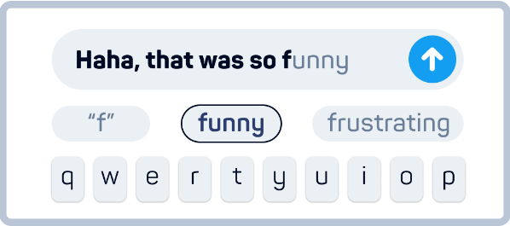

* **Corpus:** Text information fed to a model.
* Through ***corpus***, a **language model** can predict what word will come **next** when user writes something.

**For example:**

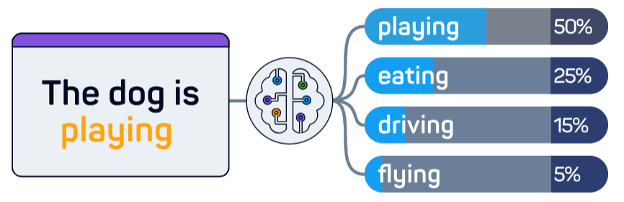

* The model uses the same process when generating **email**, **story** or **essay**.
* It keeps repeating this **probability-based** process until it has produced whole **email**, **story** or **essay** etc.
* **Temperature:** Tells how **randomly** an AI can respond.

**For example:**

